Katalyst-CDCS® Case Launching Ceremony
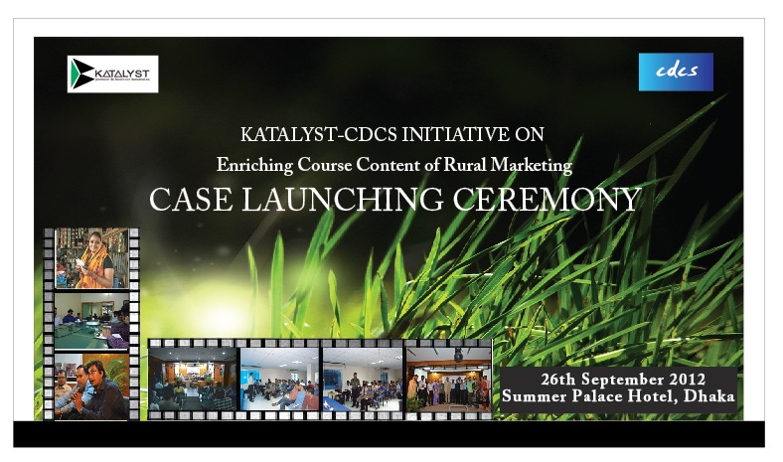
The Center for Development & Competitive Strategies Ltd. (CDCS®) organized the first-ever Case Launching Ceremony to introduce a set of Bangladesh-context teaching cases to be used in the business schools and management development institutions of the country. The program, organized in collaboration with Swisscontact Katalyst, was held on 26 September 2012 in Dhaka.

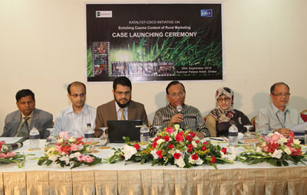
During the program, some Bangladesh-context business teaching cases developed at CDCS® were handed over to partner universities. The launching was followed by a discussion session on rural marketing scenario in Bangladesh and the importance of rural-urban integration and commitment towards creation of home-grown knowledge, with special attention to mainstreaming the base of the pyramid (BoP) business and economic activities.
The session was moderated by Prof. Dr. Rahim B. Talukdar, President of CDCS® Knowledge Institute. Prof. Dr. Abdur Rab, Vice-President (Research) of CDCS® Knowledge Institute offered the welcome note, while Chief Executive Ms. Syeda Farzana Morshed introduced the cases to the distinguished audience.
The program was participated by industry leaders, experts, and business school professors from different partner universities. The industry experts came from companies such as PRAN, Rahimafrooz, Rural Services Foundation, Novartis, Partex-Star group, Agora, Meena bazaar etc. Deans and faculty members from University of Dhaka, AIUB, Eastern University, South East University and ULAB were present in that ceremony.
Newspaper link: http://www.banglanews24.com/detailsnews.php?nssl=3b13132b64d8adf1ded92adce88bab0c&nttl=20120927103837141552

